AI ASSISTED CODING

NAME: SHARIKHA IMTIAZ KHAN

ROLLNO:2403A52368

TASK 1: Paste a function with a missing colon (add(a, b)), and let AI fix the syntax error.

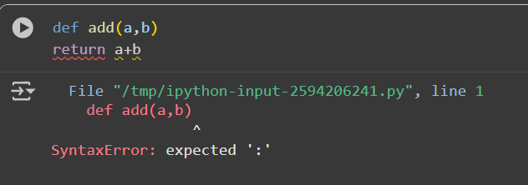

EXPLANATION: -

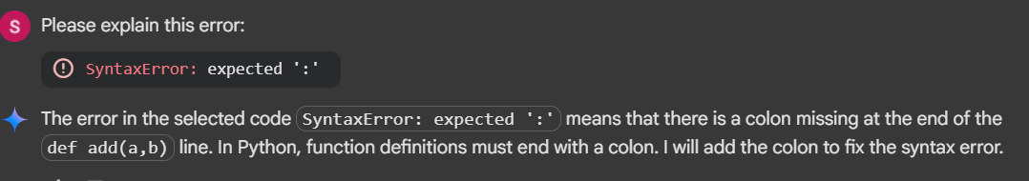

CORRECTED: -

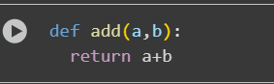

TASK 2: Identify and fix a logic error in a loop that causes infinite iteration

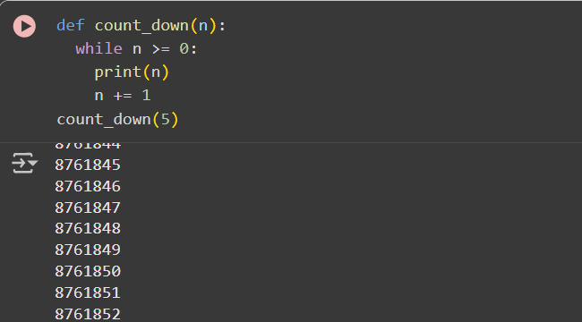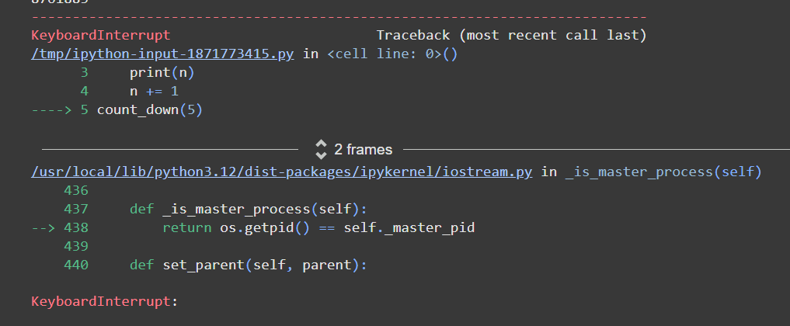

EXPLANATION:

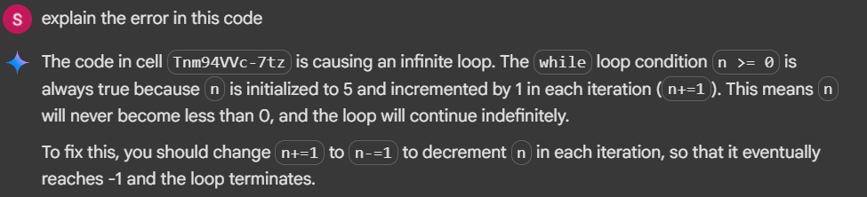

CORRECTED: -

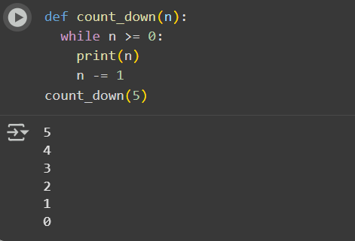

TASK 3: Debug a runtime error caused by division by zero. Let AI insert try-except.

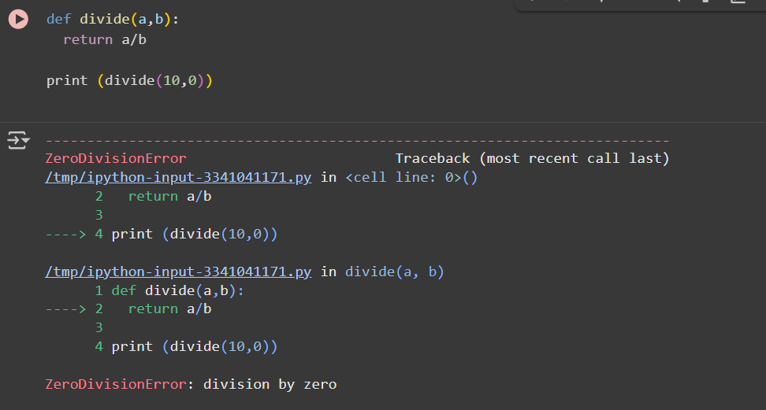

EXPLANATION: -

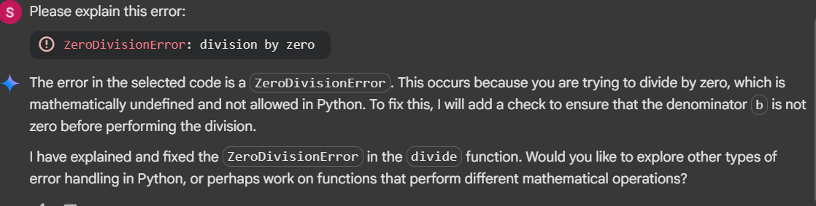

CORRECTED:

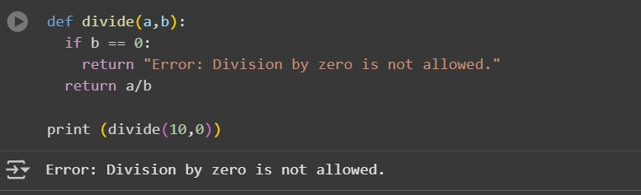

TASK 4: Provide a faulty class definition (missing self in parameters). Let AI fix it

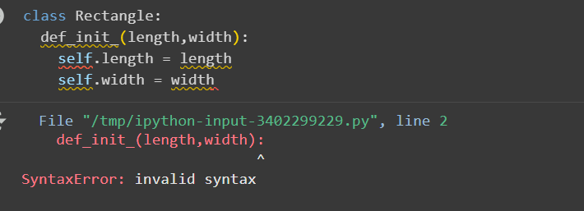

EXPLANATION: -

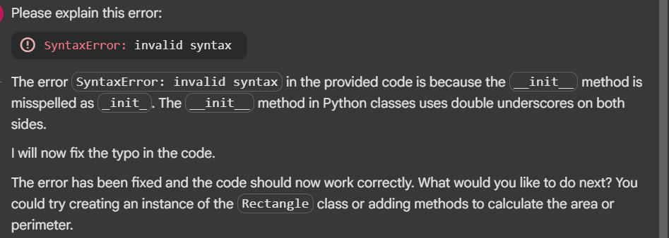

CORRECTED: -

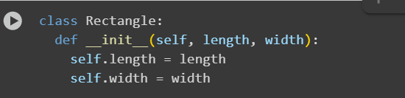

TASK 5: Access an invalid list index and use AI to resolve the Index Error.

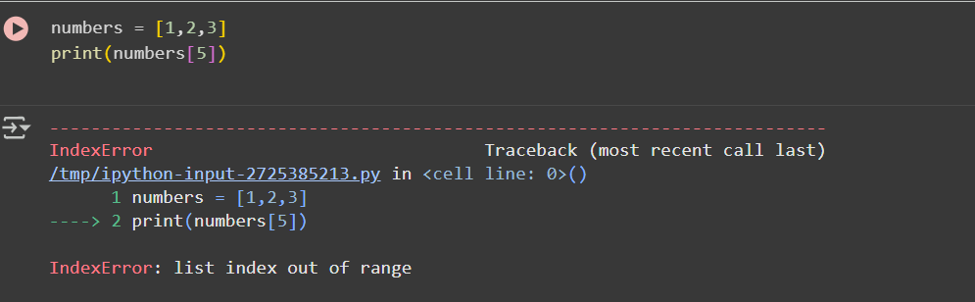

EXPLANATION: -

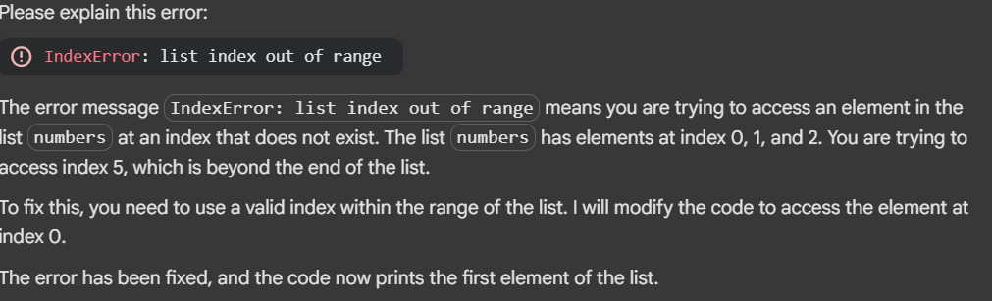

CORRECTED: -



